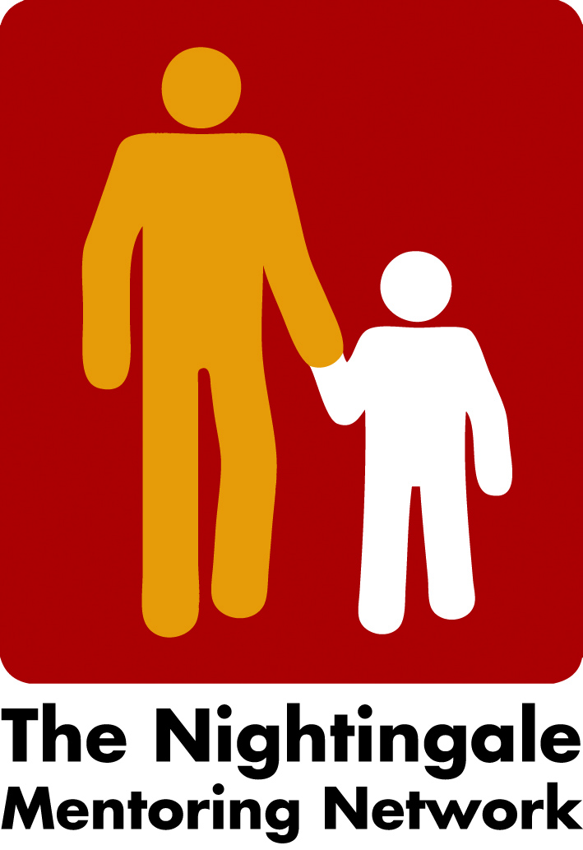

Minutes board meeting the 15th of September

- Network meeting 2022, the 24th of February, Norway
A draft agenda is done by Liv. The keynote speaker will be Sunil Loona, a psychologist. The dinner in the evening is nice planned with a cultural event.
We have already decided the theme supervision but now decided to focus on the supervision as; self- reflection, that mentoring is not only learning by doing but learning by reflective doing, as Dewey once said. We would like to focus on the supervision as one way of re-storying, or rethink- making new narratives.
First day we will have short presentation of research, why supervision, how often, the content, and individual and group sessions. The supervisor’s role, experience, the distal perspective etc.
We will have three or four short presentations of supervisions. Peter will introduce with the pilot project he and Tamina (Nightingale Switzerland) have had, IRIS (Intercultural Reflective Interactive Space Carina will give one example: Narratives by experiences. Another example from the mentor’s perspective will hopefully be” The Nightingale Linz”, analyze of data from 78 diary entries (2015 - 2018).
Liv will try to summarize our discussions and send it to Peter and Carina, then we will discuss it again. Peter will think about ways to summarize everything the second day.
- Newsletter
We hope to make a draft version of the agenda so that next newsletter will be “out” approximately in the end of September.
- Next board meeting
Thursday the 7Th of October at 2 o´clock
/Carina

