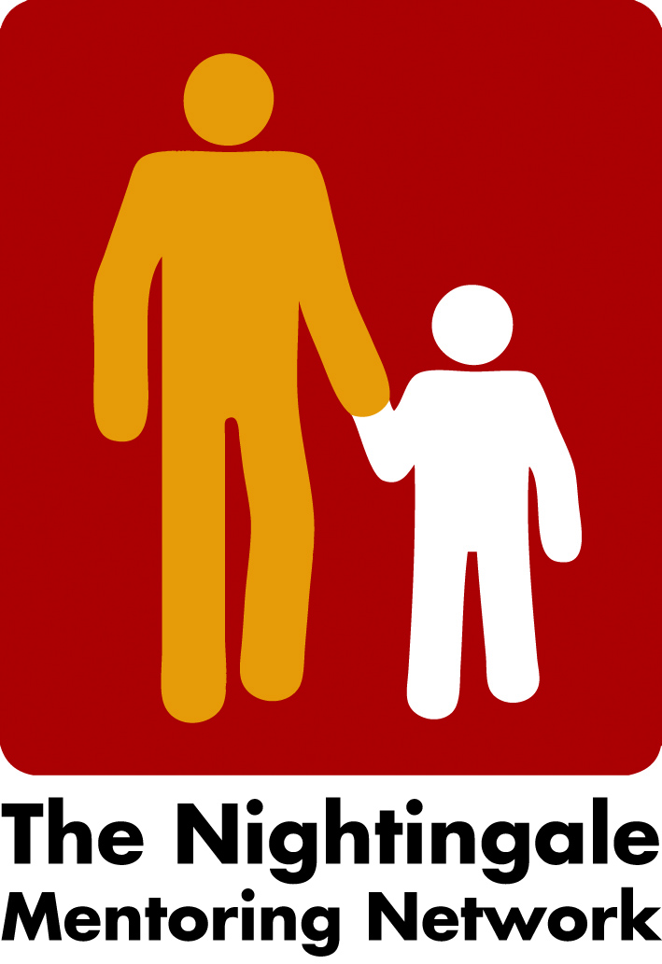

Minutes board meeting the 7th of October

- Network meeting/Conference in Lillehammer, 2022
The draft version of the agenda is almost finished now.
Last date to apply has been decided to be the 15th of November. Liv will decide the Conference fee soon.
Liv will get help from the Communication Office at Lillehammer university to make a webpage, which will be linked to the Nightingale webpage.
Tamina and Peter will make a draft of how we can use the hours for the workshop. We will discuss that at next board meeting.
Liv will contact Elisabeth Arensen regarding her presentation and Carina will contact Karl Wegeschimmel, in Linz, if he is willing to present the research, he and his colleague made about mentor’s diaries from 2015-19.
- Next board meeting 4 of November at 2 o´clock.

/Carina

