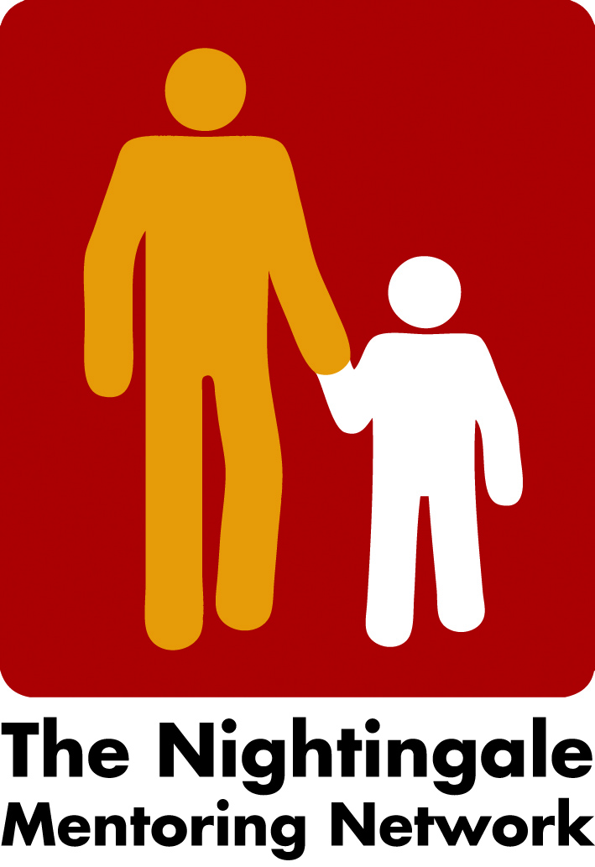

Minutes from zoom meeting Thursday the 4th of November

- The blog for the Conference and Network Meeting the 24th of February
The blog is now ready:
https://www.inn.no/om-hogskolen/fakultet-for-helse-og-sosialvitenskap/arrangementer-fra-hsv/nattergalkonferansen/index.html
However ever we still have to continue our discussion about the workshop. One idea is to have a digital tool to summarize the partners discussion. Peter will present it next time, together with Tamina who has used it a lot in seminars etc. with students.
Liv will present the content of the program at Nattergalens next national Network meeting (in Norway) and discuss the agenda for the days and maybe new ideas will come up.
Carina has written to Karl again hoping to get a reply regarding their evaluation about mentor’s diary’s – a possible presentation the 24th of February.
We will all spread the blog in own network and social media.
- Next board meeting
Suggestion for next board meeting: the 7th of December or the 10th of December at 2 o´clock.

/Carina

