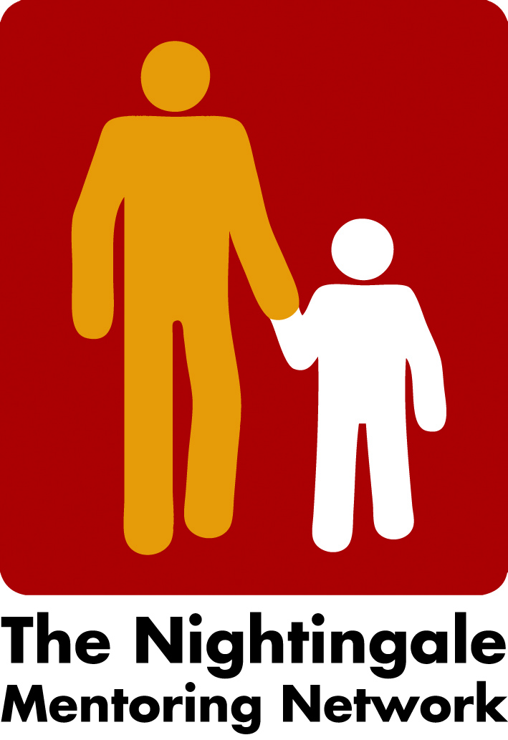

Minutes from Zoom meeting the 7th of December, 2021

- Lillehammer 2022
The board has decided to cancel the physically Network Meeting in Lillehammer the 24th – 25th of February 2022 because of the Covid situation and restriction regarding travel.
Karl and Margit have now also announced they will join the network meeting by zoom and they will present their work with the diaries.
- Peter and Taminas Workshop idea
We will use the whiteboard idea https://miro.com/de/ for our seminars where members can interact and share ideas with each other. We will also use breakout rooms. Peter will review the agenda and see where it can be used.
We decided to have one undemanding start with the tool, then seminars and maybe breakout room /pubs in the evening.
Liv will check the cost regarding if it is still possible to have the cultural event as well let the Keynote speaker deliver the lecture.
Carina will write about it all in the December Newsletter.
- Next board meeting
Next board Meeting will be the 10th of January 2021 at 2 o´clock.

/Carina

