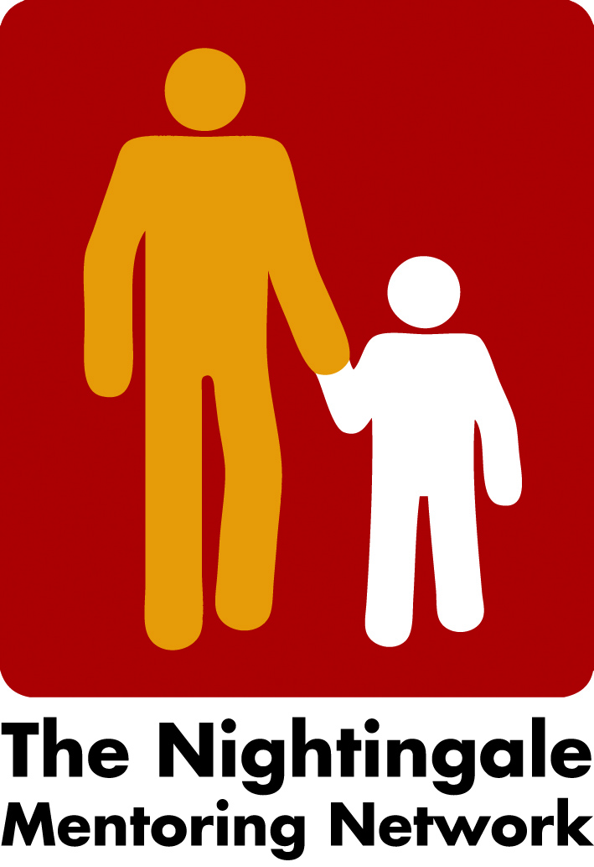

Minutes Zoom meeting the 10th of January 2022

- New schedule/agenda for the Conference and Network meeting, Zoominar the 24th of February 2022
The board change the agenda a little since the Conference are not arrange physically because of the pandemic situation and will instead by at Zoom. However, the Keynote speaker and seminars will be as scheduled. Also, the Cultural event.
Peter will introduce the Miro board which we hope to use between the presentations.
A link will be sent to all registered. Last day for registration will be the 18th of February.
Lillehammer University are willing to pay for the Keynote speakers and cultural event. So, for members it will be free to attend!
The gathering in the evening will be one hour, Carian will try to find some activities for this.
Liv will finalize the program and send it to board for feed-back. Carina will then put it on the webpage and send e-mail to all members. Members will also be encouraged to invite mentors, contact persons and other working with them.

- Next board meeting the 21 of February at 2 o´clock
We will then decide how to make break out rooms or plenum discussion depending on how many registrations we have.

/Carina

