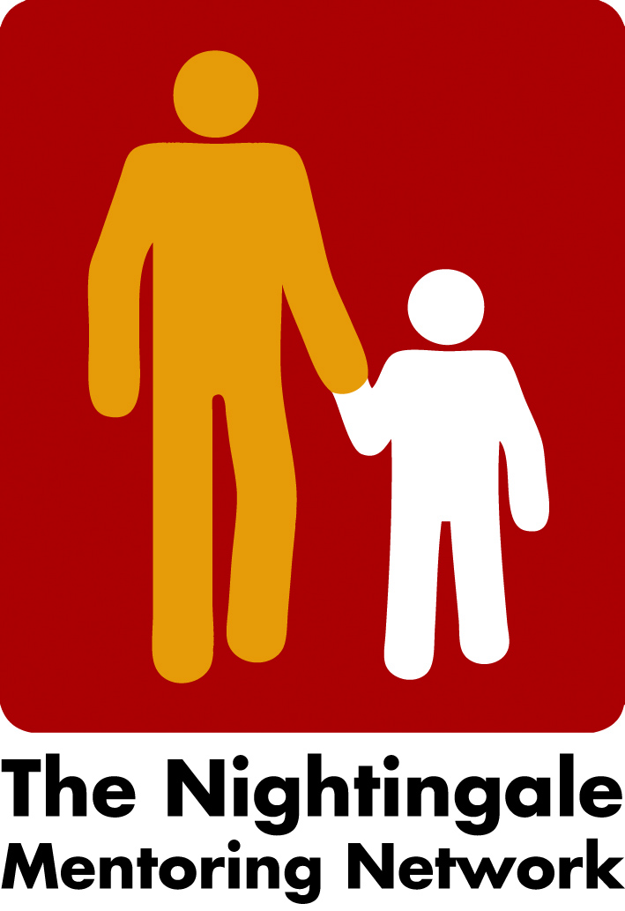
Peter Stammerjohann
Liv Randi Roland
Carina Sild Lönroth

Minutes Zoom meeting the twenty first of February 2022

- Lillehammer 2022
The board went through the agenda/the program. Our roles, the time for each block etc. So far 46 participants have registered, which is good. All countries and almost all cities will be represented. In the coming invitation Liv will remind partners to put their name on the zoom picture and their belonging to the University, organization, or the city. Carina will let partners wave from each country then in the breaking rooms they can present themselves more carefully.
Only one link will be needed to both two days and the evening gathering.
Liv will send a new agenda to everyone together with the zoom link.
Liv will also prepare a guided virtual tour in Lillehammer for partners to do in the evening and Carina and her team in Malmö will let partners do a Kahoot.
Peter will prepare some questions for the evaluation, and we will have the word Reflect, re-think and re-story as keys.
Peter, Li and Carina will meet 6 o´clock before the evening to summarize the first day and how to continue if something is needed to be changed etc.
Liv will do the groups for the breakup rooms.
/Carina

