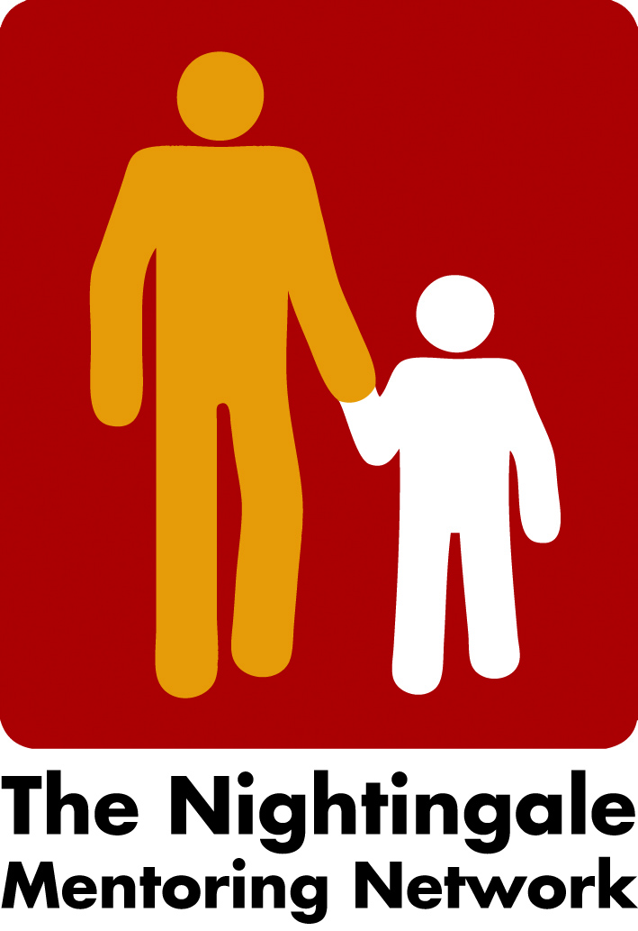

Minutes board meeting the 19th of October 2022

- Network meeting and gathering after Covid
Berlin will try to host the Network Meeting the 23-24th of February 2023. We discussed the fee of around 50 € which then will include rooms for discussions, coffee and maybe dinner in the evening. Peter will check everything.
We will later discuss the agenda and content of the Meeting. We preliminary decided the Network meeting will be from the afternoon the 23rd and end in the afternoon the 24th.
- We decided to try to share our photos from all Nightingale start-day/Kick Off and share them and other partners photo in the next coming newsletter as well on social media.

- Next board meeting
Next board meeting will be the 17th of November at 3 o´clock.

/Carina

