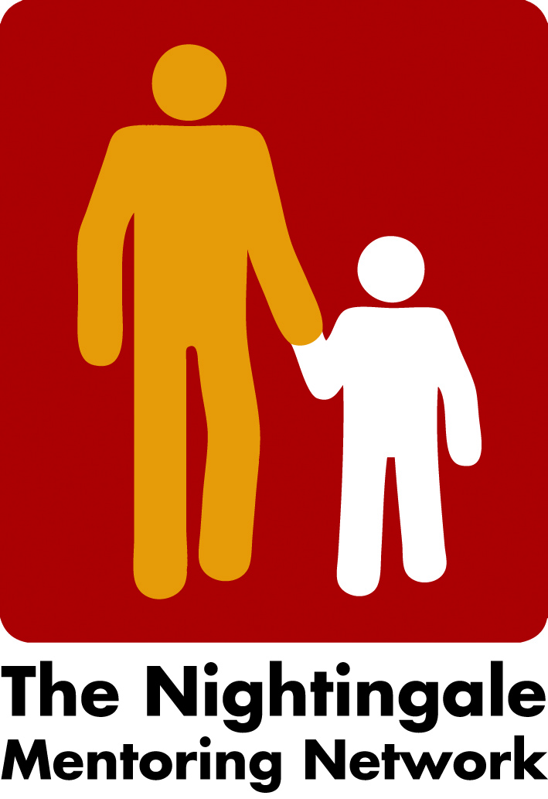

Minutes Zoom meeting the 4th of January 2023

Network meeting in Berlin February 2023
The draft version of the agenda for the Network Meeting in Berlin were discussed. The title of the Network Meeting will be The Nightingale - Past, Present and Future. We agreed on to highlight what has been and will be in the future with the Nightingale values, by reflecting and compare our ideas with UN Agenda 2030. We also discussed the aim/ what are we hoping for?
We tried to focus on why, how, and what the aim is for this meeting or what we are hoping for
The program will be put on the webpage after Peter having a meeting with his colleagues, Monday morning the 9th of January.

- Next board meeting
17th of January at 2 o´clock

/Carina

